Supplementary files.
Trait | MAS25  (Mean ± S.E.) | IB370  (Mean ± S.E.) | MAS25 × IB370 F₃ population (100 plants)
 |  |  | Range | Mean ± S.E.
Plant height (cm) | 95.9 ± 0.55 | 99.6 ± 0.28 | 80-135 | 106 ± 0.97
Effective number of tillers/plant | 10.4 ± 0.93 | 9 ± 0.62 | 8-24 | 14 ± 0.81
Panicle length (cm) | 21.9 ± 0.47 | 19.1 ± 0.45 | 14.1-25.5 | 20 ± 0.51
1000-grain weight (g) | 21.1 ± 0.49 | 20.7 ± 0.50 | 10.2-26.8 | 21 ± 0.58
Grain yield/plant (g) | 13.3 ± 0.72 | 10.2 ± 0.72 | 8.1-26.8 | 19 ± 0.82
Grain length-breadth ratio | 4.2 ± 0.15 | 4.6 ± 0.13 | 3.2-5.4 | 4 ± 0.27
Table S1: Mean and range for physio-morphological traits of MAS25 × IB370 F₃ population evaluated in the field under aerobic conditions.
Trait | MAS25  (Mean ± S.E.) | IB370  (Mean ± S.E.) | MAS25 × IB370 F₄ population (100 plants)
 |  |  | Range | Mean ± S.E.
Plant height (cm) | 94.8 ± 0.79 | 100.6 ± 0.40 | 82-130 | 101.9 ± 0.34
Effective number of tillers/plant | 14.4 ± 0.21 | 12.4 ± 0.95 | 7-23 | 13.7 ± 0.05
Panicle length (cm) | 21.2 ± 0.27 | 20.19 ± 0.14 | 17-29 | 21.8 ± 0.48
1000-grain weight (g) | 23.2 ± 0.63 | 19.0 ± 0.51 | 13.2-30.5 | 20.1 ± 0.65
Grain yield/plant (g) | 14.6 ± 0.55 | 12.2 ± 0.84 | 8.4-31.6 | 15.6 ± 0.37
Grain length-breadth ratio | 4.3 ± 0.22 | 4.7 ± 37 | 3.9-5.0 | 4.2 ± 0.22
Table S2: Mean and range for various physio-morphological traits of MAS25 × IB370 F₄ population based on field evaluation under aerobic conditions.
Trait | Plant height  (cm) | Effective no of tillers/plant | Panicle length  (cm) | 1000-grain weight  (g) | Grain yield/plant (g) | L/B ratio
Plant height (cm) | 1
Effective no. of tillers/plant | 0.618** | 1
Panicle length (cm) | 0.066 | 0.248* | 1
1000-grain weight (g) | 0.458** | 0.444** | 0.401** | 1
Grain yield/plant (g) | 0.296** | 0.316** | 0.275** | 0.277** | 1
L/B ratio | 0.365** | 0.292** | 0.045NS | 0.185 | -0.014 | 1
Table S3: Correlation coefficients among physio-morphological traits of MAS25 × IB370 F₃ population grown under aerobic conditions in the field. *Significant at 5%; ** Significant at 1% level; NS Non-Significant.
Trait | Plant height (cm) | Effective no. of tillers/plant | Panicle length  (cm) | 1000-grain weight  (g) | Grain yield/plant  (g) | L/B ratio
Plant height (cm) | 1
Effective no. of tillers/plant | 0.397** | 1
Panicle length (cm) | 0.816** | 0.446** | 1
1000-grain weight (g) | 0.798** | 0.407** | 0.817** | 1
Grain yield/plant (g) | 0.159 | 0.418** | 0.293** | 0.119 | 1
L/B ratio | 0.486** | 0.186 | 0.415** | 0.346** | 0.027 | 1
Table S4: Correlation coefficients among physio-morphological traits of MAS25 × IB370 F₄ population grown under aerobic conditions. *Significant at 5%; ** Significant at 1% level.
Trait | MAS25  (Mean ± S.E.) | IB370  (Mean ± S.E.) | MAS25 × IB370 F₃ plants (62 plants)
 |  |  | Range | Mean ± S.E.
Plant height (cm) | 80.2 ± 0.90 | 91.0 ± 0.61 | 52-98 | 72 ± 0.50
Effective no. of tillers/ plant | 5.6 ± 0.84 | 4.1 ± 0.52 | 2-8 | 4.6 ± 0.75
Panicle length (cm) | 17.6 ± 0.48 | 16.0 ± 0.85 | 10.3-24.2 | 17.7 ± 0.82
Grain yield/plant (g) | 5.4 ± 0.45 | 4.2 ± 0.56 | 0.2-5.7 | 1.6 ± 1.05
1000-grain weight (g) | 13.7 ± 0.21 | 12.6 ± 0.82 | 9.3-16.7 | 12.3 ± 0.44
L/B ratio | 3.9 ± 0.11 | 4.0 ± 0.30 | 3.1-4.3 | 3.6 ± 0.15
Root length (cm) | 40.3 ± 0.19 | 36.2 ± 0.80 | 34.5-57 | 43.8 ± 0.87
Root thickness (mm) | 12.4 ± 0.68 | 11.8 ± 0.69 | 6.3-16.8 | 12.3 ± 0.74
Fresh root weight (g) | 10.1 ± 0.47 | 8.11 ± 0.63 | 2.2-16.8 | 10.2 ± 0.18
Dry root weight (g) | 2.6 ± 0.67 | 2.2 ± 0.47 | 0.9-7.5 | 3.2 ± 0.80
Table S5: Mean and range for various physio-morphological and root traits of MAS25 × IB370 F₃ plants grown under water limited aerobic condition in the net house.
Trait | MAS25  (Mean ± S.E.) | IB370  (Mean ± S.E.) | MAS25 × IB370 F₄ plants (14 plants)
 |  |  | Range | Mean ± S.E.
Plant height (cm) | 85.1 ± 0.12 | 94.5 ± 0.31 | 83-105 | 95.2 ± 0.72
Effective no. of tillers/plant | 8.1 ± 0.10 | 7.2 ± 0.87 | 5-10 | 6.9 ± 0.69
Panicle length (cm) | 19.4 ± 0.65 | 16.5 ± 0.12 | 12.3-21.7 | 17.3 ± 0.67
Grain yield/plant (g) | 7.6 ± 0.26 | 5.1 ± 0.21 | 1.1-6.8 | 3.3 ± 0.94
1000-grain weight (g) | 13.6 ± 0.13 | 13.5 ± 0.54 | 15.3-19.8 | 17.6 ± 0.36
L/B ratio | 3.8 ± 0.21 | 4.1 ± 0.11 | 3.4-4.7 | 4.0 ± 0.17
Root length (cm) | 43.9 ± 0.13 | 39.2 ± 0.30 | 38.5-57.8 | 46.1 ± 0.93
Root thickness (mm) | 15.5 ± 0.98 | 13.1 ± 0.49 | 6.1-9.8 | 8.6 ± 0.36
Fresh root weight (g) | 9.56 ± 0.34 | 7.0 ± 0.13 | 9.2-20.9 | 13.7 ± 0.88
Dry root weight (g) | 2.1 ± 0.57 | 1.98 ± 0.24 | 1.7-5.3 | 3.6 ± 0.55
Table S6: Mean and range for various physio-morphological and root traits of MAS25 × IB370 F₄ plants grown under water-limited aerobic conditions in the net house.
Trait | Plant height(cm) | Effective no. of tillers/ plant | Panicle length (cm) | 1000-grain weight (g) | Grain yield/plant (g) | L/B ratio | Root length (cm) | Root thickness (mm) | Fresh root weight (g) | Dry root weight (g)
Plant height (cm) | 1
Effective no. of tillers/plant | 0.129 | 1
Panicle length (cm) | -0.047 | 0.076 | 1
1000-grain weight (g) | 0.12 | 0.260* | 0.378** | 1
Grain yield/plant (g) | 0.250* | 0.416** | -0.051 | 0.036 | 1
L/B ratio | 0.076 | 0.072 | -0.063 | -0.172 | 0.062 | 1
Root length (cm) | 0.408** | 0.317* | -0.025 | 0.11 | 0.033 | 0.111 | 1
Root thickness (mm) | -0.006 | -0.162 | -0.182 | -0.182 | -0.205 | -0.058 | -0.163 | 1
Fresh root weight (g) | 0.432** | 0.368** | -0.088 | 0.141 | 0.174 | -0.116 | 0.435** | 0.164 | 1
Dry root weight (g) | 0.254* | 0.168 | -0.092 | -0.078 | 0.102 | -0.03 | 0.361** | 0.275* | 0.613** | 1
Table S7: Correlation coefficients among physio-morphological traits of MAS25 × IB370 F₃ population under aerobic conditions in net house. *Significant at 5%; ** Significant at 1% level.
Trait | Plant height (cm) | Effective no. of tillers/plant | Panicle length (cm) | 1000-grain weight (g) | Grain yield/ plant (g) | L/B ratio | Root length (cm) | Root thickness (mm) | Fresh root weight (g) | Dry root weight (g)
Plant height (cm) | 1
Effective no. of tillers/plant | -0.156 | 1
Panicle length (cm) | 0.138 | 0.368 | 1
1000-grain weight (g) | 0.907** | -0.203 | 0.289 | 1
Grain yield/plant (g) | 0.903** | -0.235 | 0.047 | 0.939** | 1
L/B ratio | 0.917** | -0.228 | 0.048 | 0.939** | 0.964** | 1
Root length (cm) | 0.578* | -0.369 | 0.122 | 0.630* | 0.619* | 0.639* | 1
Root thickness (mm) | 0.945** | -0.063 | 0.246 | 0.853** | 0.826** | 0.853** | 0.581* | 1
Fresh root weight (g) | 0.926** | -0.284 | 0.03 | 0.937** | -0.264 | -0.086 | -0.139 | -0.16 | 1
Dry root weight (g) | 0.943** | -0.109 | 0.181 | 0.921** | 0.946** | 0.949** | 0.639* | 0.908** | 0.938** | 1
Table S8: Correlation coefficients among physio-morphological traits of MAS25 × IB370 F4 plants grown under aerobic conditions in net house. *Significant at 5%; ** Significant at 1% level.

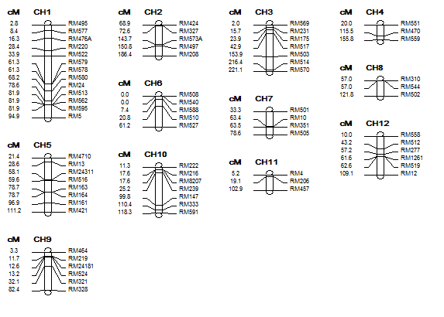
Figure S1: Mapped locations of 70 SSR markers on rice chromosomes covering the entire rice.

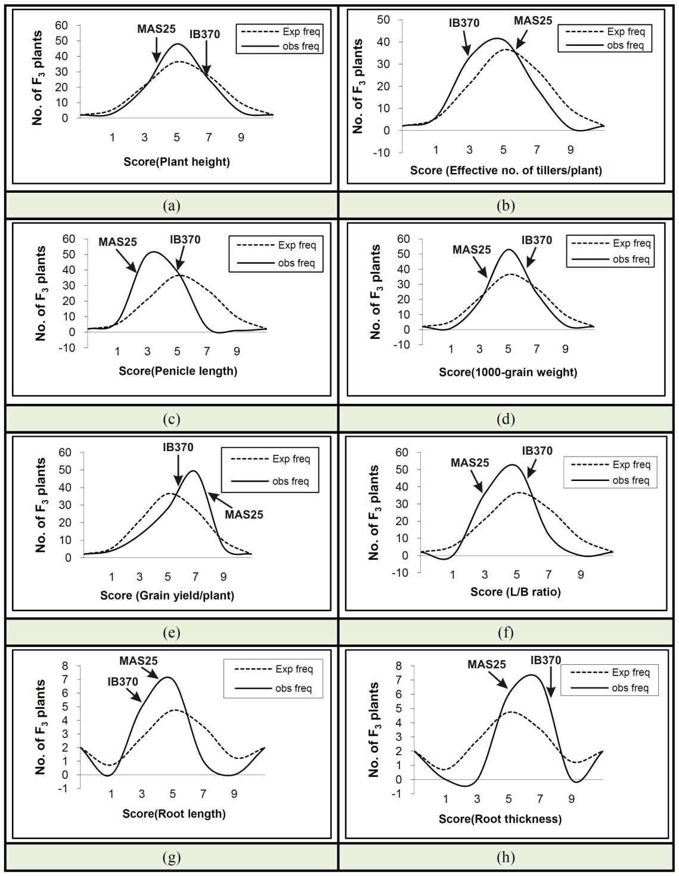
Figure S2: Frequency distribution curves for physio-morphological and root traits of MAS25 x IB370 F₃ population grown under aerobic condition in the field (a-f) and net house (g & h).

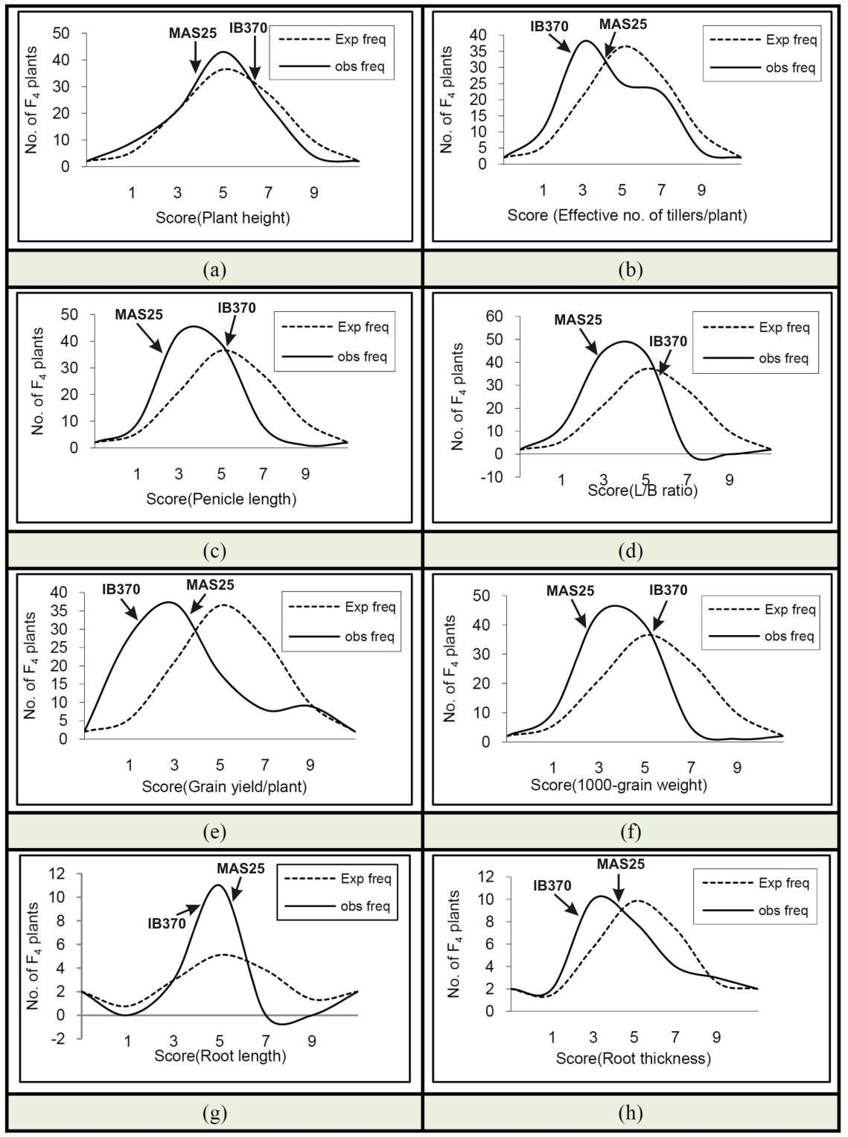
Figure S3: Frequency distribution curves for physio-morphological and root traits of MAS25 x IB370 F4 populations grown under aerobic conditions in the field (a-f) and net house (g & h).

